## 

## **2017 Celebrating 100 years Lions**

In 2017 all three Dutch camps came together to celebrate the 100 years existence of Lions International. In an unique Dutch way: walking over the sandbanks between the islands in the north.

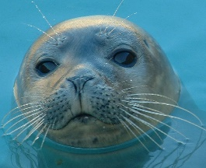In red, white and blue T shirts the participants and campstaff, together100 people formed the Dutch flag. First a trip with a boat along the seals who linger there. Then on old sneakers walking along the sandbanks, who flood now and then (don’t worry, we know exactly when). Real Dutch culture for all participants. On a cold day with rain, also very Dutch. The weather changes a lot.

Nice to meet all campers in Holland, we had fun together despite the cold. Back on the boat first all mud had to be washed off, before we went to the ‘Schippershuus’ (sailershouse), to have a warm and Dutch diner, with of course Dutch fish and chips, and ‘boerenjongens’ (raisins in brandy).

